**PROJECT DEVELOPMENT PHASE**

**SPRINT-3**

|  |  |
| --- | --- |
| **Date** | 10 November 2022 |
| **Team ID** | PNT2022TMID10231 |
| **Project name** | Airline Data Analytics for Aviation Industry |

According to sprint delivery plan in sprint 3 task is to personalise the dashboard from the given data set . By using the dataset we have preformed the dashboard analytics view

**DASHBOARD 1**

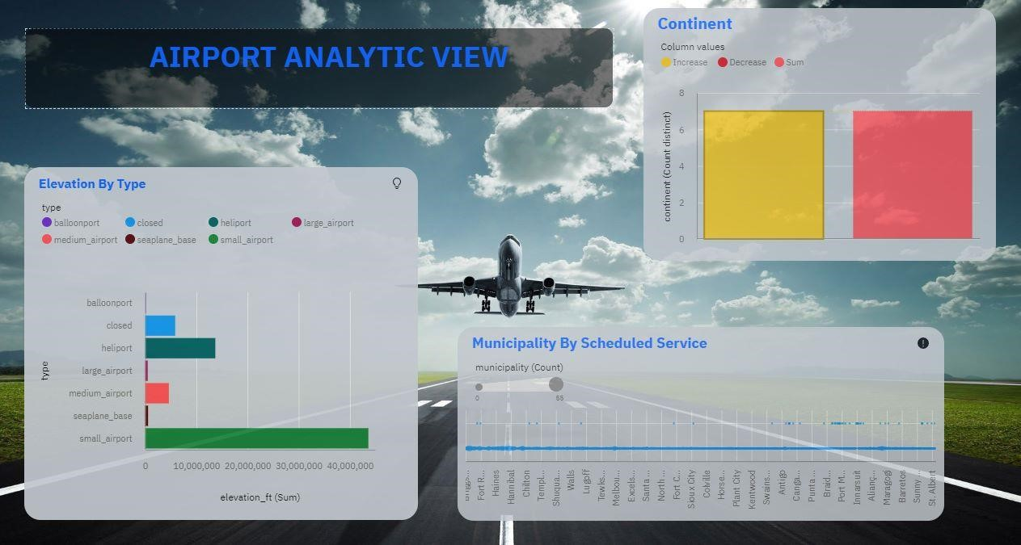

Dashboard url:

**DASHBOARD 2**

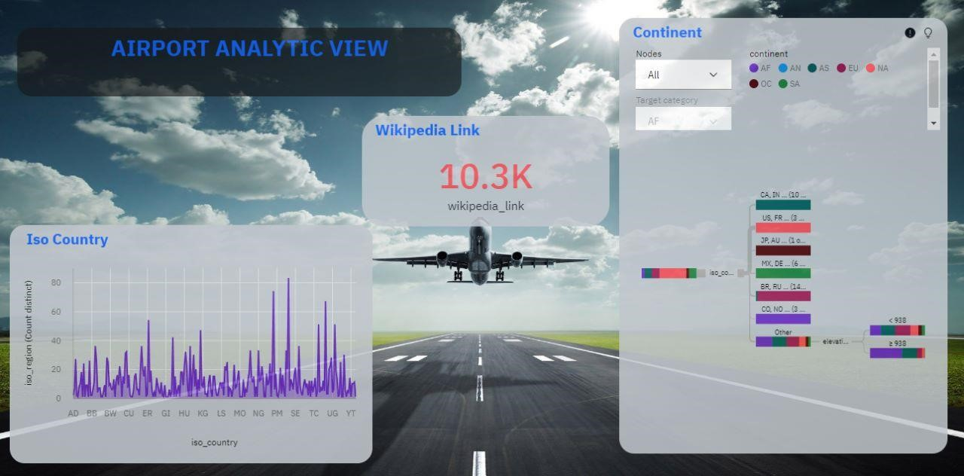

**DASHBOARD 3:**

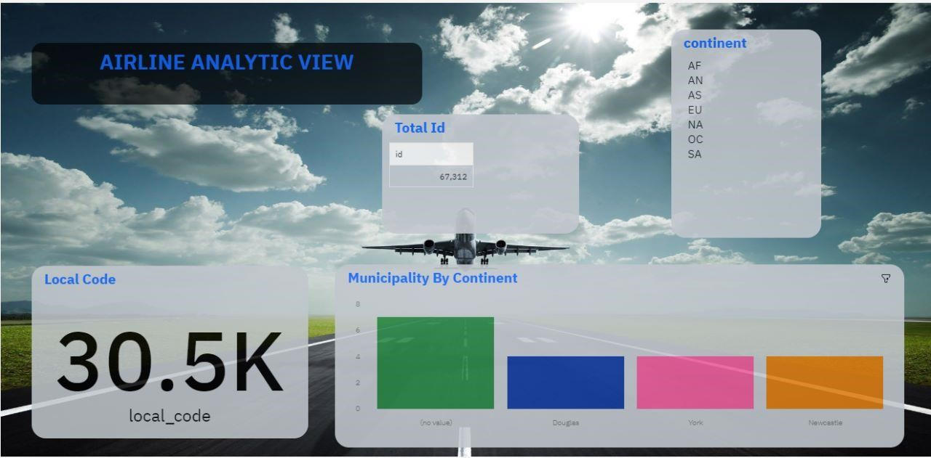

**DASHBOARD 4:**

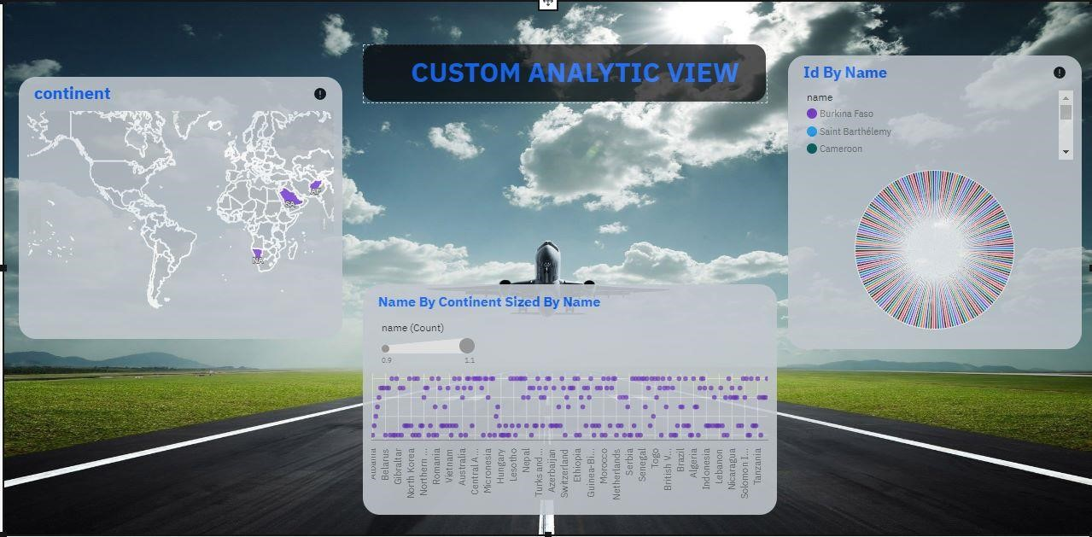

**DASHBOARD 5:**

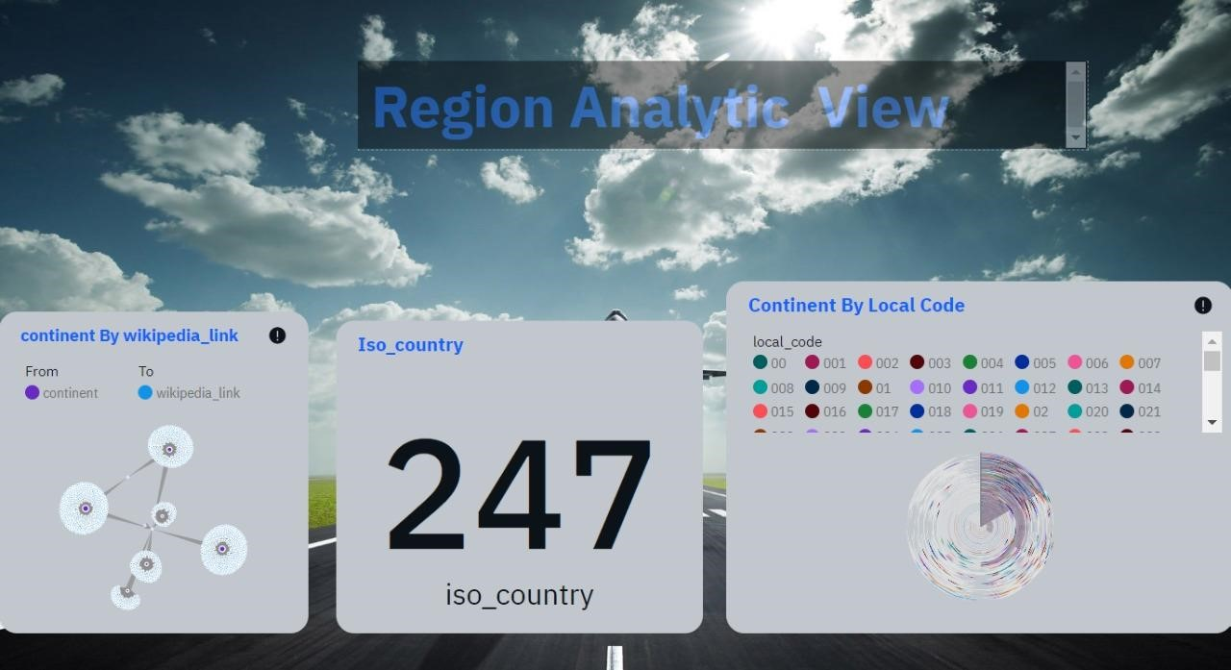

**DASHBOARD 6:**

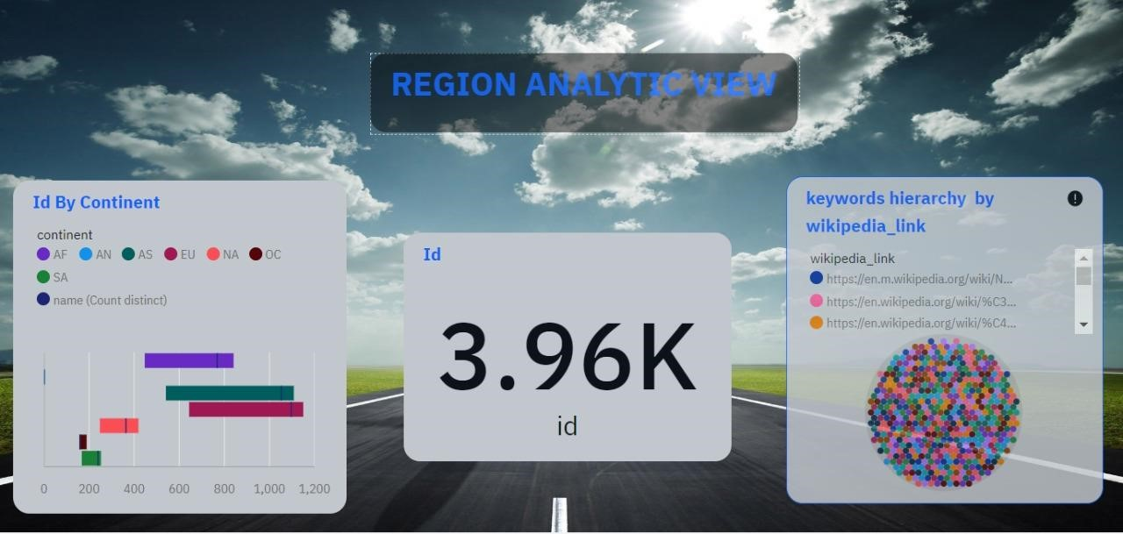

In such a way dashboard are created, edited and saved in IBM COGNOS ANALYTICS

